CHAPTER 3

TEACHING NOTES

For undergraduates, I do not work through most of the derivations in this chapter, at least not in detail. Rather, I focus on interpreting the assumptions, which mostly concern the population. Other than random sampling, the only assumption that involves more than population considerations is the assumption about no perfect collinearity, where the possibility of perfect collinearity in the sample (even if it does not occur in the population) should be touched on. The more important issue is perfect collinearity in the population, but this is fairly easy to dispense with via examples. These come from my experiences with the kinds of model specification issues that beginners have trouble with.

The comparison of simple and multiple regression estimates – based on the particular sample at hand, as opposed to their statistical properties – usually makes a strong impression. Sometimes I do not bother with the “partialling out” interpretation of multiple regression.

As far as statistical properties, notice how I treat the problem of including an irrelevant variable: no separate derivation is needed, as the result follows form Theorem 3.1.

I do like to derive the omitted variable bias in the simple case. This is not much more difficult than showing unbiasedness of OLS in the simple regression case under the first four Gauss-Markov assumptions. It is important to get the students thinking about this problem early on, and before too many additional (unnecessary) assumptions have been introduced.

I have intentionally kept the discussion of multicollinearity to a minimum. This partly indicates my bias, but it also reflects reality. It is, of course, very important for students to understand the potential consequences of having highly correlated independent variables. But this is often beyond our control, except that we can ask less of our multiple regression analysis. If two or more explanatory variables are highly correlated in the sample, we should not expect to precisely estimate their ceteris paribus effects in the population.

I find extensive treatments of multicollinearity, where one “tests” or somehow “solves” the multicollinearity problem, to be misleading, at best. Even the organization of some texts gives the impression that imperfect multicollinearity is somehow a violation of the Gauss-Markov assumptions: they include multicollinearity in a chapter or part of the book devoted to “violation of the basic assumptions,” or something like that. I have noticed that master’s students who have had some undergraduate econometrics are often confused on the multicollinearity issue. It is very important that students not confuse multicollinearity among the included explanatory variables in a regression model with the bias caused by omitting an important variable.

I do not prove the Gauss-Markov theorem. Instead, I emphasize its implications. Sometimes, and certainly for advanced beginners, I put a special case of Problem 3.12 on a midterm exam, where I make a particular choice for the function g(x). Rather than have the students directly compare the variances, they should appeal to the Gauss-Markov theorem for the superiority of OLS over any other linear, unbiased estimator.
SOLUTIONS TO PROBLEMS

3.1 (i) hsperc is defined so that the smaller it is, the lower the student’s standing in high school. Everything else equal, the worse the student’s standing in high school, the lower is his/her expected college GPA.

(ii) Just plug these values into the equation:

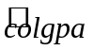 = 1.392 − .0135(20) + .00148(1050) = 2.676.

(iii) The difference between A and B is simply 140 times the coefficient on sat, because hsperc is the same for both students. So A is predicted to have a score .00148(140) .207 higher.

(iv) With hsperc fixed, 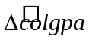 = .00148Δsat. Now, we want to find Δsat such that = .5, so .5 = .00148(Δsat) or Δsat = .5/(.00148) 338. Perhaps not surprisingly, a large ceteris paribus difference in SAT score – almost two and one-half standard deviations – is needed to obtain a predicted difference in college GPA or a half a point.

3.2 (i) Yes. Because of budget constraints, it makes sense that, the more siblings there are in a family, the less education any one child in the family has. To find the increase in the number of siblings that reduces predicted education by one year, we solve 1 = .094(Δsibs), so Δsibs = 1/.094 10.6.

(ii) Holding sibs and feduc fixed, one more year of mother’s education implies .131 years more of predicted education. So if a mother has four more years of education, her son is predicted to have about a half a year (.524) more years of education.

(iii) Since the number of siblings is the same, but meduc and feduc are both different, the coefficients on meduc and feduc both need to be accounted for. The predicted difference in education between B and A is .131(4) + .210(4) = 1.364.

3.3 (i) If adults trade off sleep for work, more work implies less sleep (other things equal), so 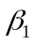 < 0.

(ii) The signs of 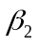 and 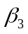 are not obvious, at least to me. One could argue that more educated people like to get more out of life, and so, other things equal, they sleep less ( < 0). The relationship between sleeping and age is more complicated than this model suggests, and economists are not in the best position to judge such things.

(iii) Since totwrk is in minutes, we must convert five hours into minutes: Δtotwrk = 5(60) = 300. Then sleep is predicted to fall by .148(300) = 44.4 minutes. For a week, 45 minutes less sleep is not an overwhelming change.

(iv) More education implies less predicted time sleeping, but the effect is quite small. If we assume the difference between college and high school is four years, the college graduate sleeps about 45 minutes less per week, other things equal.

(v) Not surprisingly, the three explanatory variables explain only about 11.3% of the variation in sleep. One important factor in the error term is general health. Another is marital status, and whether the person has children. Health (however we measure that), marital status, and number and ages of children would generally be correlated with totwrk. (For example, less healthy people would tend to work less.)

3.4 (i) A larger rank for a law school means that the school has less prestige; this lowers starting salaries. For example, a rank of 100 means there are 99 schools thought to be better.

(ii) > 0, > 0. Both LSAT and GPA are measures of the quality of the entering class. No matter where better students attend law school, we expect them to earn more, on average. , 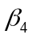 > 0. The number of volumes in the law library and the tuition cost are both measures of the school quality. (Cost is less obvious than library volumes, but should reflect quality of the faculty, physical plant, and so on.)

(iii) This is just the coefficient on GPA, multiplied by 100: 24.8%.

(iv) This is an elasticity: a one percent increase in library volumes implies a .095% increase in predicted median starting salary, other things equal.

(v) It is definitely better to attend a law school with a lower rank. If law school A has a ranking 20 less than law school B, the predicted difference in starting salary is 100(.0033)(20) = 6.6% higher for law school A.

3.5 (i) No. By definition, study + sleep + work + leisure = 168. Therefore, if we change study, we must change at least one of the other categories so that the sum is still 168.

(ii) From part (i), we can write, say, study as a perfect linear function of the other independent variables: study = 168 − sleep − work − leisure. This holds for every observation, so MLR.3 violated.

(iii) Simply drop one of the independent variables, say leisure:

GPA = 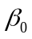 + study + sleep + work + u.

Now, for example, is interpreted as the change in GPA when study increases by one hour, where sleep, work, and u are all held fixed. If we are holding sleep and work fixed but increasing study by one hour, then we must be reducing leisure by one hour. The other slope parameters have a similar interpretation.

3.6 Conditioning on the outcomes of the explanatory variables, we have 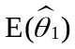 = E(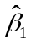 + 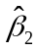) = E() + E() = β₁ + β₂ = 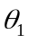.

3.7 Only (ii), omitting an important variable, can cause bias, and this is true only when the omitted variable is correlated with the included explanatory variables. The homoskedasticity assumption, MLR.5, played no role in showing that the OLS estimators are unbiased. (Homoskedasticity was used to obtain the usual variance formulas for the 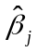.) Further, the degree of collinearity between the explanatory variables in the sample, even if it is reflected in a correlation as high as .95, does not affect the Gauss-Markov assumptions. Only if there is a perfect linear relationship among two or more explanatory variables is MLR.3 violated.

3.8 We can use Table 3.2. By definition, > 0, and by assumption, Corr(x₁,x₂) < 0. Therefore, there is a negative bias in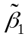: E() < . This means that, on average across different random samples, the simple regression estimator underestimates the effect of the training program. It is even possible that E() is negative even though > 0.

3.9 (i) < 0 because more pollution can be expected to lower housing values; note that is the elasticity of price with respect to nox. is probably positive because rooms roughly measures the size of a house. (However, it does not allow us to distinguish homes where each room is large from homes where each room is small.)

(ii) If we assume that rooms increases with quality of the home, then log(nox) and rooms are negatively correlated when poorer neighborhoods have more pollution, something that is often true. We can use Table 3.2 to determine the direction of the bias. If > 0 and Corr(x₁,x₂) < 0, the simple regression estimator has a downward bias. But because < 0, this means that the simple regression, on average, overstates the importance of pollution. [E() is more negative than .]

(iii) This is what we expect from the typical sample based on our analysis in part (ii). The simple regression estimate, −1.043, is more negative (larger in magnitude) than the multiple regression estimate, −.718. As those estimates are only for one sample, we can never know which is closer to. But if this is a “typical” sample, is closer to −.718.

3.10 (i) Because  is highly correlated with  and , and these latter variables have large partial effects on y, the simple and multiple regression coefficients on can differ by large amounts. We have not done this case explicitly, but given equation (3.46) and the discussion with a single omitted variable, the intuition is pretty straightforward.

(ii) Here we would expect 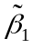 and 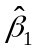 to be similar (subject, of course, to what we mean by “almost uncorrelated”). The amount of correlation between and does not directly effect the multiple regression estimate on if is essentially uncorrelated with and.

(iii) In this case we are (unnecessarily) introducing multicollinearity into the regression: and have small partial effects on y and yet and are highly correlated with. Adding and like increases the standard error of the coefficient on substantially, so se() is likely to be much larger than se().

(iv) In this case, adding and will decrease the residual variance without causing much collinearity (because is almost uncorrelated with and), so we should see se() smaller than se(). The amount of correlation between and does not directly affect se().

3.11 From equation (3.22) we have

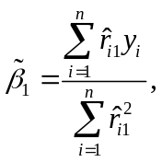

where the 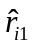 are defined in the problem. As usual, we must plug in the true model for y_{i}:

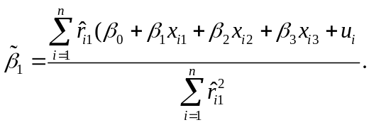

The numerator of this expression simplifies because 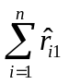 = 0, 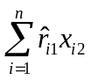 = 0, and 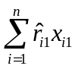 = 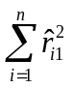. These all follow from the fact that the are the residuals from the regression of 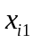 on 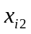: the have zero sample average and are uncorrelated in sample with . So the numerator of can be expressed as

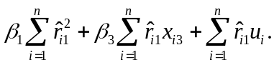

Putting these back over the denominator gives

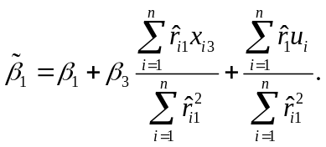

Conditional on all sample values on x_{1,} x₂, and x₃, only the last term is random due to its dependence on u_{i}. But E(u_{i}) = 0, and so

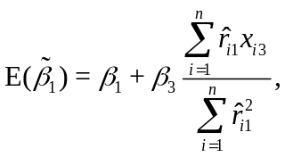

which is what we wanted to show. Notice that the term multiplying is the regression coefficient from the simple regression of x_{i3} on .

3.12 (i) The shares, by definition, add to one. If we do not omit one of the shares then the equation would suffer from perfect multicollinearity. The parameters would not have a ceteris paribus interpretation, as it is impossible to change one share while holding all of the other shares fixed.

(ii) Because each share is a proportion (and can be at most one, when all other shares are zero), it makes little sense to increase share_{p} by one unit. If share_{p} increases by .01 – which is equivalent to a one percentage point increase in the share of property taxes in total revenue – holding share_{I}, share_{S}, and the other factors fixed, then growth increases by (.01). With the other shares fixed, the excluded share, share_{F}, must fall by .01 when share_{p} increases by .01.

3.13 (i) For notational simplicity, define s_{zx} = 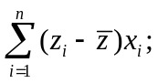 this is not quite the sample covariance between z and x because we do not divide by n – 1, but we are only using it to simplify notation. Then we can write as

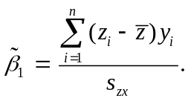

This is clearly a linear function of the y_{i}: take the weights to be w_{i} = (z_{i} −)/s_{zx}. To show unbiasedness, as usual we plug y_{i} = + x_{i} + u_{i} into this equation, and simplify:

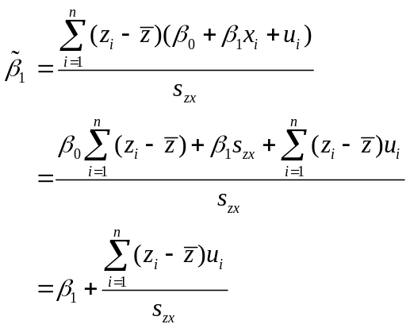

where we use the fact that 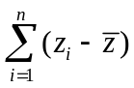 = 0 always. Now s_{zx} is a function of the z_{i} and x_{i} and the expected value of each u_{i} is zero conditional on all z_{i} and x_{i} in the sample. Therefore, conditional on these values,

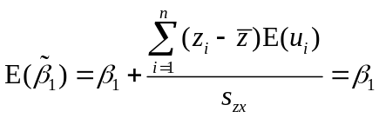

because E(u_{i}) = 0 for all i.

(ii) From the fourth equation in part (i) we have (again conditional on the z_{i} and x_{i} in the sample),

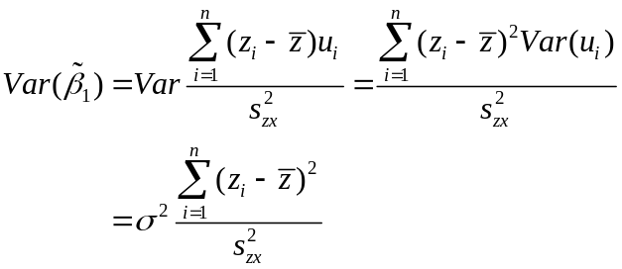

because of the homoskedasticity assumption [Var(u_{i}) = σ² for all i]. Given the definition of s_{zx}, this is what we wanted to show.

(iii) We know that Var() = σ²/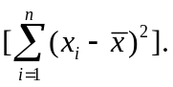 Now we can rearrange the inequality in the hint, drop from the sample covariance, and cancel n⁻¹ everywhere, to get 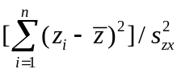 ≥ 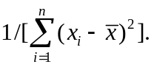 When we multiply through by σ² we get Var() ≥ Var(), which is what we wanted to show.

SOLUTIONS TO COMPUTER EXERCISES

C3.1 (i) Probably > 0, as more income typically means better nutrition for the mother and better prenatal care.

(ii) On the one hand, an increase in income generally increases the consumption of a good, and cigs and faminc could be positively correlated. On the other, family incomes are also higher for families with more education, and more education and cigarette smoking tend to be negatively correlated. The sample correlation between cigs and faminc is about −.173, indicating a negative correlation.

(iii) The regressions without and with faminc are

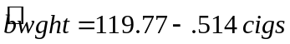
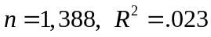
and
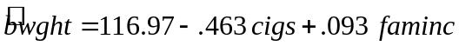
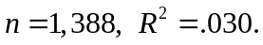

The effect of cigarette smoking is slightly smaller when faminc is added to the regression, but the difference is not great. This is due to the fact that cigs and faminc are not very correlated, and the coefficient on faminc is practically small. (The variable faminc is measured in thousands, so $10,000 more in 1988 income increases predicted birth weight by only .93 ounces.)

C3.2 (i) The estimated equation is

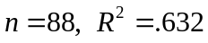

(ii) Holding square footage constant, 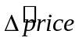 = 15.20 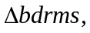 and so 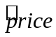 increases by 15.20, which means $15,200.

(iii) Now = .128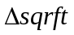 + 15.20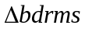 = .128(140) + 15.20 = 33.12, or $33,120. Because the size of the house is increasing, this is a much larger effect than in (ii).

(iv) About 63.2%.

(v) The predicted price is –19.32 + .128(2,438) + 15.20(4) = 353.544, or $353,544.

(vi) From part (v), the estimated value of the home based only on square footage and number of bedrooms is $353,544. The actual selling price was $300,000, which suggests the buyer underpaid by some margin. But, of course, there are many other features of a house (some that we cannot even measure) that affect price, and we have not controlled for these.

C3.3 (i) The constant elasticity equation is

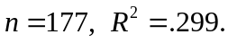

(ii) We cannot include profits in logarithmic form because profits are negative for nine of the companies in the sample. When we add it in levels form we get

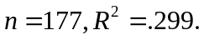

The coefficient on profits is very small. Here, profits are measured in millions, so if profits increase by $1 billion, which means 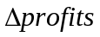 = 1,000 – a huge change – predicted salary increases by about only 3.6%. However, remember that we are holding sales and market value fixed.
Together, these variables (and we could drop profits without losing anything) explain almost 30% of the sample variation in log(salary). This is certainly not “most” of the variation.

(iii) Adding ceoten to the equation gives

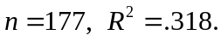

This means that one more year as CEO increases predicted salary by about 1.2%.

(iv) The sample correlation between log(mktval) and profits is about .78, which is fairly high. As we know, this causes no bias in the OLS estimators, although it can cause their variances to be large. Given the fairly substantial correlation between market value and firm profits, it is not too surprising that the latter adds nothing to explaining CEO salaries. Also, profits is a short term measure of how the firm is doing while mktval is based on past, current, and expected future profitability.

C3.4 (i) The minimum, maximum, and average values for these three variables are given in the table below:

Variable | Average | Minimum | Maximum
atndrte  priGPA  ACT | 81.71  2.59  22.51 | 6.25  .86  13 | 100  3.93  32

(ii) The estimated equation is

n = 680, R² = .291.

The intercept means that, for a student whose prior GPA is zero and ACT score is zero, the predicted attendance rate is 75.7%. But this is clearly not an interesting segment of the population. (In fact, there are no students in the college population with priGPA = 0 and ACT = 0, or with values even close to zero.)

(iii) The coefficient on priGPA means that, if a student’s prior GPA is one point higher (say, from 2.0 to 3.0), the attendance rate is about 17.3 percentage points higher. This holds ACT fixed. The negative coefficient on ACT is, perhaps initially a bit surprising. Five more points on the ACT is predicted to lower attendance by 8.6 percentage points at a given level of priGPA. As priGPA measures performance in college (and, at least partially, could reflect, past attendance rates), while ACT is a measure of potential in college, it appears that students that had more promise (which could mean more innate ability) think they can get by with missing lectures.

(iv) We have 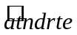 = 75.70 + 17.267(3.65) – 1.72(20) 104.3. Of course, a student cannot have higher than a 100% attendance rate. Getting predictions like this is always possible when using regression methods for dependent variables with natural upper or lower bounds. In practice, we would predict a 100% attendance rate for this student. (In fact, this student had an actual attendance rate of 87.5%.)

(v) The difference in predicted attendance rates for A and B is 17.26(3.1 − 2.1) − (21 − 26) = 25.86.

C3.5 The regression of educ on exper and tenure yields

educ = 13.57 − .074 exper + .048 tenure + .
n = 526, R² = .101.

Now, when we regress log(wage) on we obtain

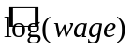 = 1.62 + .092
n = 526, R² = .207.

As expected, the coefficient on in the second regression is identical to the coefficient on educ in equation (3.19). Notice that the R-squared from the above regression is below that in (3.19). In effect, the regression of log(wage) on explains log(wage) using only the part of educ that is uncorrelated with exper and tenure; separate effects of exper and tenure are not included.

C3.6 (i) The slope coefficient from the regression IQ on educ is (rounded to five decimal places) 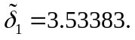

(ii) The slope coefficient from log(wage) on educ is 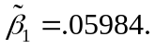

(iii) The slope coefficients from log(wage) on educ and IQ are 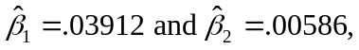respectively.

(iv) We have which is very close to .05984; the small difference is due to rounding error.

C3.7 (i) The results of the regression are

n = 408, R² = .180.

The signs of the estimated slopes imply that more spending increases the pass rate (holding lnchprg fixed) and a higher poverty rate (proxied well by lnchprg) decreases the pass rate (holding spending fixed). These are what we expect.

(ii) As usual, the estimated intercept is the predicted value of the dependent variable when all regressors are set to zero. Setting lnchprg = 0 makes sense, as there are schools with low poverty rates. Setting log(expend) = 0 does not make sense, because it is the same as setting expend = 1, and spending is measured in dollars per student. Presumably this is well outside any sensible range. Not surprisingly, the prediction of a 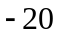 pass rate is nonsensical.

(iii) The simple regression results are

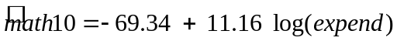
n = 408, R² = .030
and the estimated spending effect is larger than it was in part (i) – almost double.

(iv) The sample correlation between lexpend and lnchprg is about 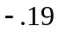, which means that, on average, high schools with poorer students spent less per student. This makes sense, especially in 1993 in Michigan, where school funding was essentially determined by local property tax collections.

(v) We can use equation (3.23). Because Corr(x₁,x₂) < 0, which means 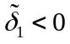, and 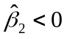, the simple regression estimate, , is larger than the multiple regression estimate, . Intuitively, failing to account for the poverty rate leads to an overestimate of the effect of spending.

3.8 (i) The average of prpblck is .113 with standard deviation .182; the average of income is 47,053.78 with standard deviation 13,179.29. It is evident that prpblck is a proportion and that income is measured in dollars.

(ii) The results from the OLS regression are

n = 401, R² = .064.

If, say, prpblck increases by .10 (ten percentage points), the price of soda is estimated to increase by .0115 dollars, or about 1.2 cents. While this does not seem large, there are communities with no black population and others that are almost all black, in which case the difference in psoda is estimated to be almost 11.5 cents.

(iii) The simple regression estimate on prpblck is .065, so the simple regression estimate is actually lower. This is because prpblck and income are negatively correlated (-.43) and income has a positive coefficient in the multiple regression.

(iv) To get a constant elasticity, income should be in logarithmic form. I estimate the constant elasticity model:

n = 401, R² = .068.

If prpblck increases by .20, log(psoda) is estimated to increase by .20(.122) = .0244, or about 2.44 percent.

(v) 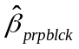 falls to about .073 when prppov is added to the regression.

(vi) The correlation is about 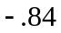, which makes sense because poverty rates are determined by income (but not directly in terms of median income).

(vii) There is no argument that they are highly correlated, but we are using them simply as controls to determine if the is price discrimination against blacks. In order to isolate the pure discrimination effect, we need to control for as many measures of income as we can; including both variables makes sense.

